Direct Debit Instructions
For Retirees

INTRODUCTION

• USG policy requires that all retirees pay premiums by direct debit for USG Benefits (retiree dental, vision, life insurance, or pre-65 healthcare coverage), regardless of whether you now pay for your coverage by either direct debit or paper billing.

• If you have direct debit now, you will need to provide your banking information again. Banking regulations prohibit us from transferring direct debit information from the current benefits administration system to the new system.

• All retirees must provide direct debit information between June 26 and
November 30, 2017 or risk loss of coverage.

STEPS

Step 1: Go to http://connect-benefits.usg.edu

Step 2: Under Manage My Benefits, select USG Retirees and COBRA
participants.

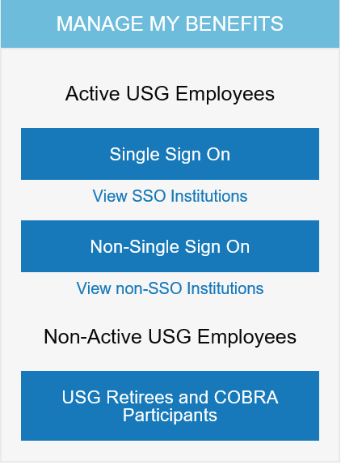

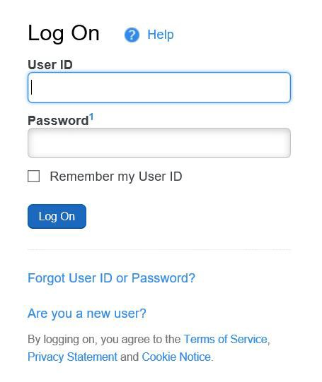Step 3: Click Are you a new user? link.

Step 4: Enter your Personal Identification to establish secure access, click
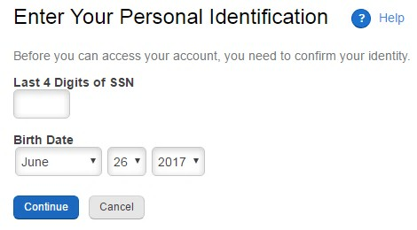Continue.

Step 5: Enter your Zip Code, Click Continue

Step 6: Next you will be prompted to create your user ID, password (needs 3 of
4 –uppercase, lowercase, number, symbol), phone pin (six digits only) and five security questions.

Step 7: Once you complete your security information, click continue.

Step 8: This brings you to the main page. It will ask you if you want a tour or skip the tour. To go to the next step, select skip tour.

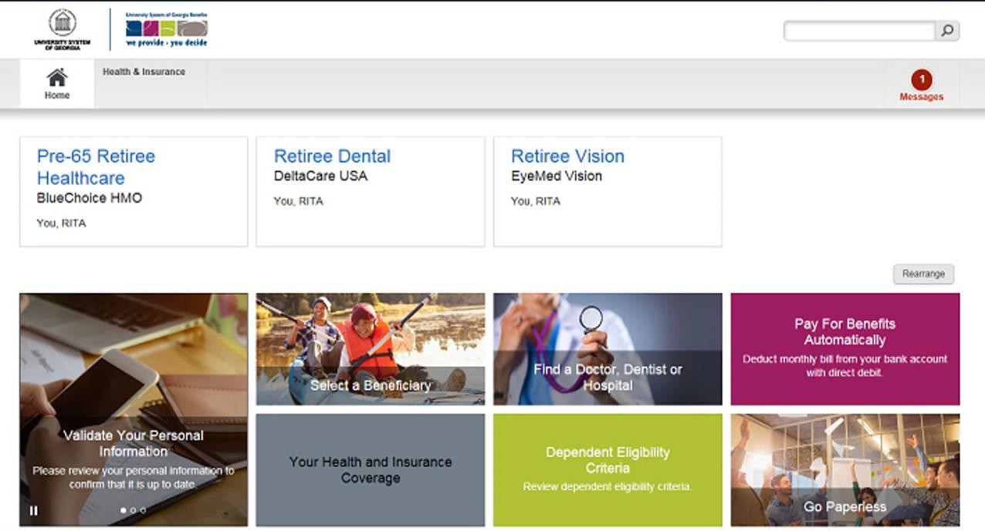

Step 9: From the OneUSG Connect – Benefits home page, click the Pay for
Benefits Automatically tile.

Step 10: Direct debit is automatically selected. From this screen, select
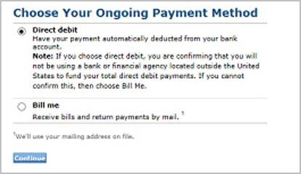Continue.

Step 11: Click Add Financial Institution.

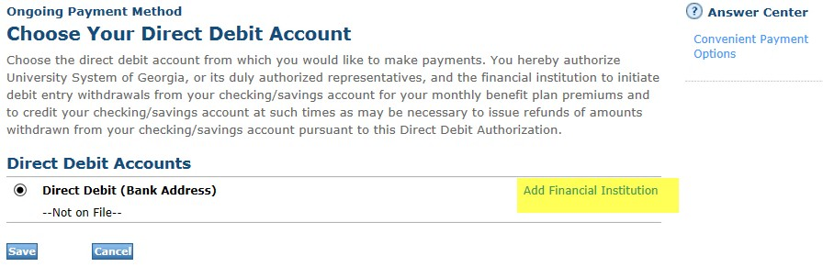

Step 12: Make sure to have your banking information available and fill in account number and routing information.

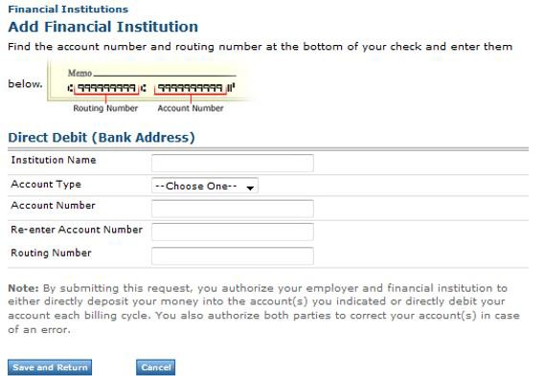

Step 13: It will ask you to verify and save again. Once complete, you will see the following message.

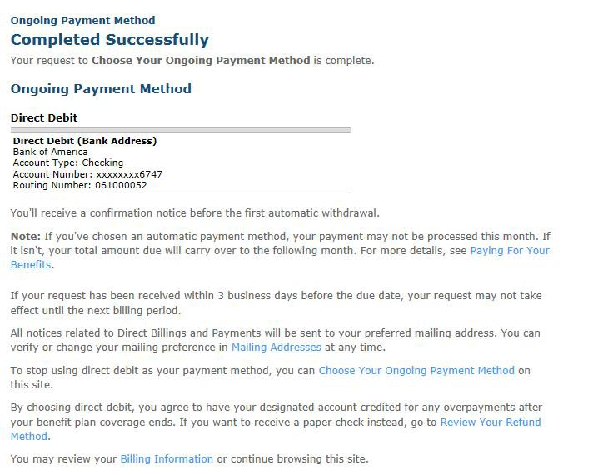

This completes the steps for setting up your Direct Debit. Remember to Log Off
(upper right corner) when you are done.

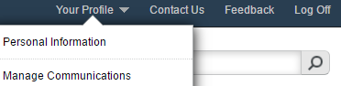Helpful Tip:

Prior to logging off, it is a good idea to check to see that your most current phone numbers are active in the system. In the upper right corner, click on
Your Profile, click on Personal Information.

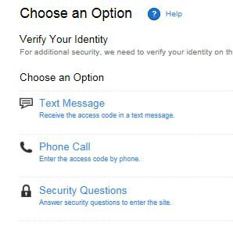When logging back into the system, you may be required to verify your identity, using one of the three methods listed below.

